Part 1: Time Trend Analysis / 时间趋势分析
1.1 Monthly Review Volume by Brand / 各品牌月度评论量趋势
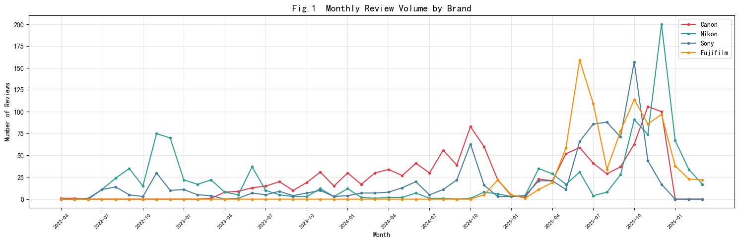
The monthly review volume reveals a clear growth trajectory across all four brands, with a pronounced acceleration beginning in mid-2025. Canon consistently leads in absolute volume, reflecting its dominant market presence in the entry-level mirrorless camera segment. Nikon and Sony demonstrate comparable volume patterns, while Fujifilm maintains the lowest but steadily growing review count.

Seasonal patterns are evident across all brands. Notable volume spikes coincide with China's major e-commerce promotional events, including the 618 Shopping Festival (June) and Singles' Day (November). For instance, all four brands exhibit significant peaks in June 2025 and October–November 2025, suggesting that promotional campaigns are a primary driver of both purchase activity and user discussion. Canon shows the sharpest promotional response, likely attributable to its larger user base and stronger price competitiveness during sales periods.

1.2 Monthly Share of Voice by Brand / 各品牌月度声量份额
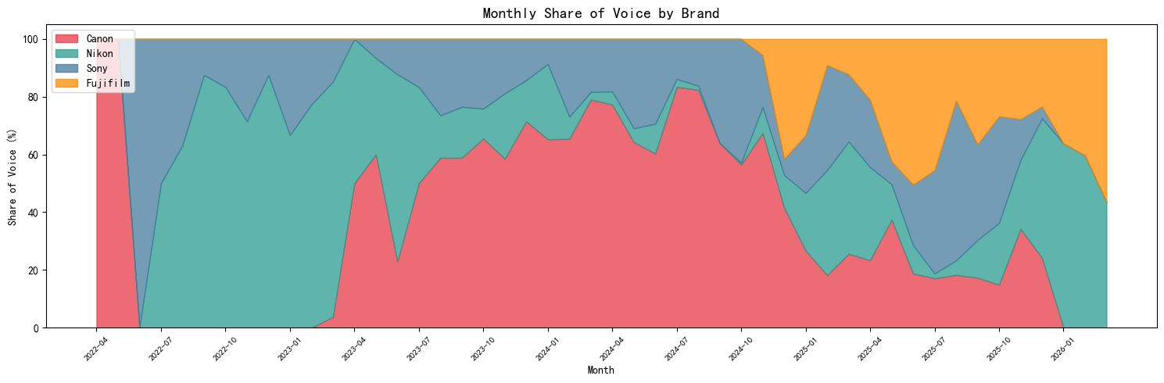
Canon consistently commands the largest share of voice at approximately 30-35%, establishing it as the most discussed brand. Nikon and Sony each hold a relatively stable 20-25% share. Fujifilm fluctuates between 15-22%, though there is a notable upward trend in certain months, suggesting growing market attention. Overall, the four brands maintain a relatively stable share distribution without any single brand dramatically displacing others in the conversation space.

1.3 Monthly Positive Sentiment Trend / 各品牌月度正面情感趋势
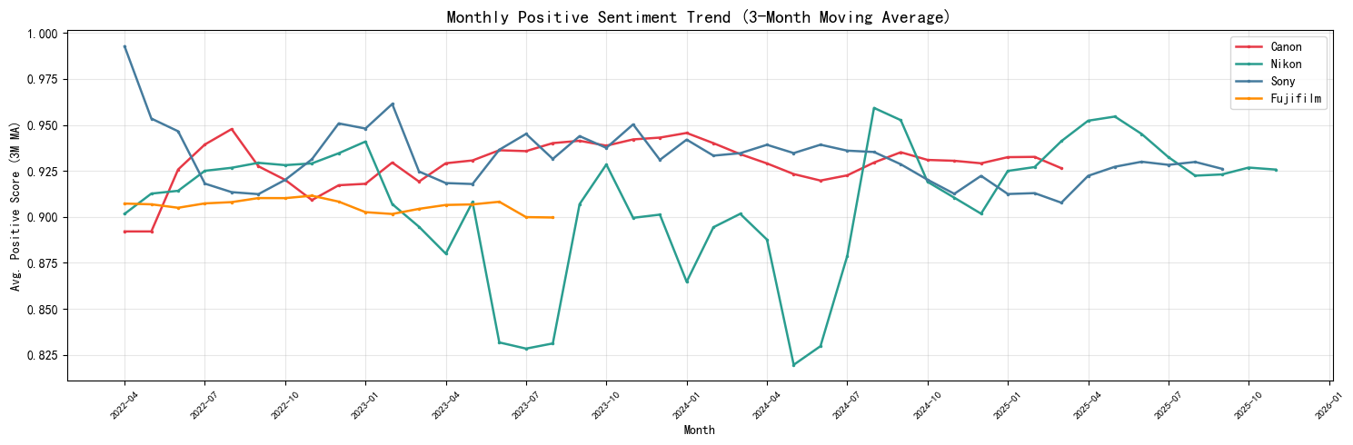
The three-month moving average of positive sentiment scores reveals that all four brands maintain high overall satisfaction levels (0.88–0.96 range), consistent with the generally positive nature of JD.com product reviews. Canon exhibits the most stable sentiment trajectory, sustaining scores around 0.93, which reflects consistent product satisfaction and reliable after-sales experience. Sony demonstrates comparable stability at approximately 0.93.

Fujifilm shows the highest sentiment volatility among the four brands. Several months exhibit notable dips to approximately 0.85–0.88, which cross-referencing with the differential keyword analysis (Part 2) reveals to be associated with stock shortage frustration — terms such as "终于" (finally), "抢到" (managed to get), and "原价" (retail price) feature prominently in Fujifilm reviews, indicating that purchase difficulty periodically depresses overall sentiment scores despite high product satisfaction.

Nikon maintains sentiment levels around 0.92, with moderate fluctuations. All brands show a slight upward trend in late 2025, potentially attributable to new product iterations and improved promotional offerings enhancing user experience.

Part 2: Brand Positioning Analysis / 品牌定位分析
2.1 Topic Distribution by Brand (Radar Chart) / 各品牌主题分布雷达图
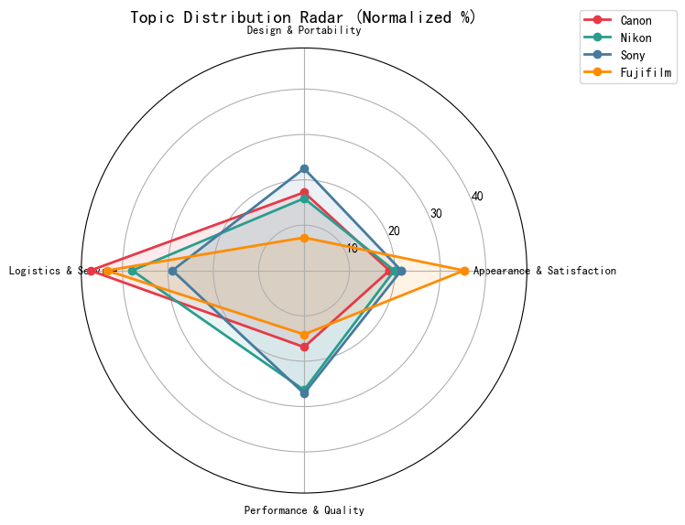
The radar chart reveals distinctly differentiated positioning among the four brands based on the four LDA-derived topic categories:

- Fujifilm exhibits a heavily skewed distribution toward "Appearance & Satisfaction" (35.2%), the highest among all brands, while its "Performance & Quality" share is the lowest (14.1%). This pattern strongly validates Fujifilm's market positioning as an aesthetics-first brand, where users prioritize visual design, retro styling, and emotional satisfaction over technical specifications.

- Sony and Nikon show the opposite pattern, with the highest shares in "Performance & Quality" (Sony: 27.1%, Nikon: 26.4%). Sony additionally maintains elevated shares in "Design & Portability" (24.6%), reflecting its dual positioning as both a performance and portability-oriented brand. Nikon's elevated "Logistics & Service" share (35.7%) suggests that Nikon users frequently comment on purchasing and delivery experiences, potentially reflecting the brand's dual-lens kit purchasing patterns.

- Canon presents the most balanced distribution across all four topics, with no single dominant dimension. Its "Logistics & Service" share (49.9%) is notably high, which aligns with its positioning as the entry-level market leader where purchase experience and service quality are particularly relevant for first-time camera buyers.

2.2 Brand-Specific Differential Keywords / 各品牌差异化关键词
方法：
1. 统计每个品牌评论中 Top50 高频词（过滤单字）
2. 取4个品牌的交集作为通用停用词自动过滤
3. 计算 TF-IDF ratio（品牌内均值 ÷ 品牌外均值），比值越高说明该词越"专属于"该品牌
4. 每个品牌取 Top8 差异化词
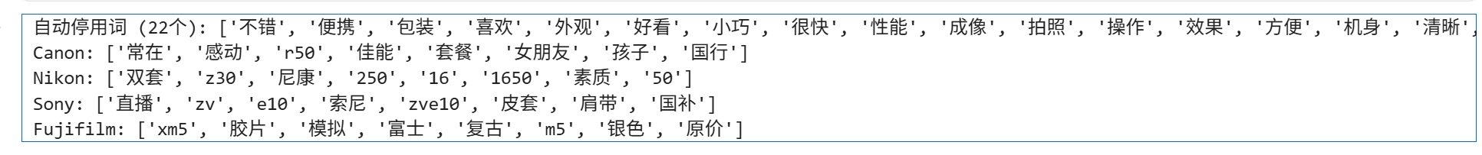
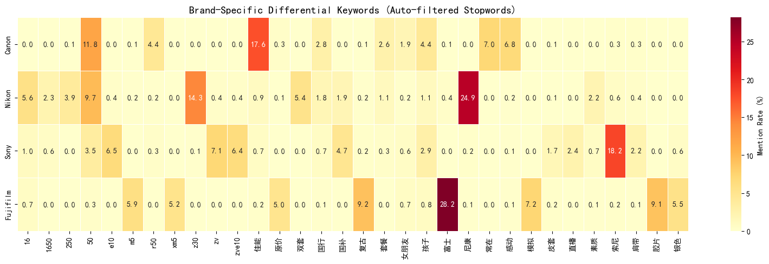
Methodology: Common stopwords were automatically generated by computing the intersection of top-50 high-frequency words across all four brands, yielding 22 universally common terms (e.g., "相机", "不错", "外观", "小巧"). These were removed prior to TF-IDF differential ratio computation (brand TF-IDF mean / non-brand TF-IDF mean) to isolate brand-specific vocabulary.

Analysis:
The differential keyword heatmap reveals the unique linguistic fingerprint of each brand's user base:

Canon is characterized by its brand slogan "感动常在" (Canon — Bringing You Closer), the model identifier "R50", and lifestyle-oriented terms such as "女朋友" (girlfriend), "孩子" (children), and "国行" (official Chinese version). This vocabulary profile indicates that Canon's primary user segment comprises photography beginners purchasing for personal or family use, with a significant gifting consumption scenario.

Nikon is distinguished by hardware-specific terminology: "Z30" (model), "双套" (dual-lens kit), "1650" and "250" (lens specifications), and "素质" (optical quality). This technical vocabulary reflects a more performance-conscious user base that evaluates lens configurations and optical characteristics during purchase decisions.

Sony uniquely features content creation terminology: "直播" (live streaming), "ZV/E10/ZVE10" (model identifiers), "皮套" (leather case), "肩带" (shoulder strap), and "国补" (government subsidy). The prevalence of video creation and accessory-related terms firmly establishes Sony ZV-E10's positioning as the vlogger and content creator's camera of choice.

Fujifilm is dominated by aesthetic and cultural terms: "胶片" (film), "模拟" (simulation), "复古" (retro), "银色" (silver), alongside scarcity indicators "原价" (retail price), "抢到" (managed to purchase). This dual vocabulary of aesthetic appreciation and purchase difficulty highlights both Fujifilm's unique brand appeal in film simulation aesthetics and its ongoing supply-demand imbalance.

2.3 Brand Positioning — Parallel Coordinates / 品牌定位平行坐标图
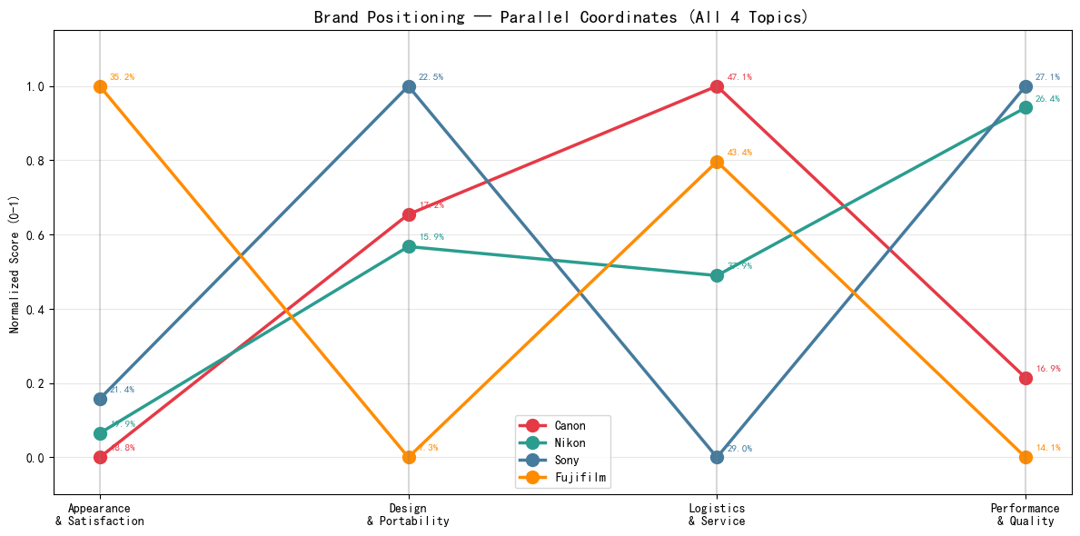
The parallel coordinates chart provides a comprehensive four-dimensional comparison of brand positioning, with each axis representing a normalized topic share (0–1 scale).

The most striking pattern is the **crossing of lines between Fujifilm and the Sony/Nikon cluster**. Fujifilm rises sharply on the Appearance dimension while descending on Performance, creating an "X" pattern with Sony and Nikon that visually encapsulates the fundamental positioning divide in the entry-level camera market: aesthetics-driven versus performance-driven purchasing motivations.

Canon maintains a distinctive mid-range profile across most dimensions but shows a pronounced peak on Logistics & Service, diverging from the other three brands. This suggests that Canon's competitive landscape is partially distinct — while the other three brands compete on product attributes (appearance vs. performance), Canon's market position is significantly influenced by its distribution and service infrastructure.

Sony demonstrates the most consistently elevated profile across Design & Portability and Performance, indicating the broadest feature appeal among the four brands.

Part 4: Feature Preference Analysis / 功能偏好分析
Methodology: This analysis directly uses the 4 LDA topic labels assigned to each review by the topic classification model .
4.1 Feature × Brand: Average Positive Sentiment Score
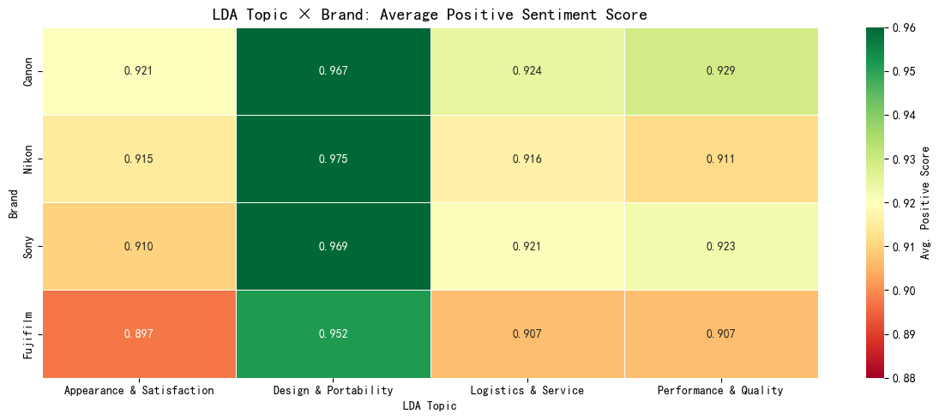
Highest dimension: Design & Portability (0.952–0.975). Nikon tops at 0.975, the single highest value in the heatmap.
Lowest dimension: Appearance & Satisfaction (0.897–0.921). Fujifilm's 0.897 is the single lowest value.
Key brand contrasts:
- Canon: highest in Performance & Quality (0.929) — R50 users are most satisfied with imaging output.
- Nikon: highest in Design & Portability (0.975) but lowest in Performance & Quality (0.911) — loves the Z30 body, wants better image quality.
- Sony: balanced, second-highest in both Performance (0.923) and Logistics (0.921).
- Fujifilm: last in all four topics. Lowest in Appearance (0.897) despite being the brand most associated with aesthetics — supply frustration overrides product satisfaction.

4.2 LDA Topic × Brand: Topic Distribution
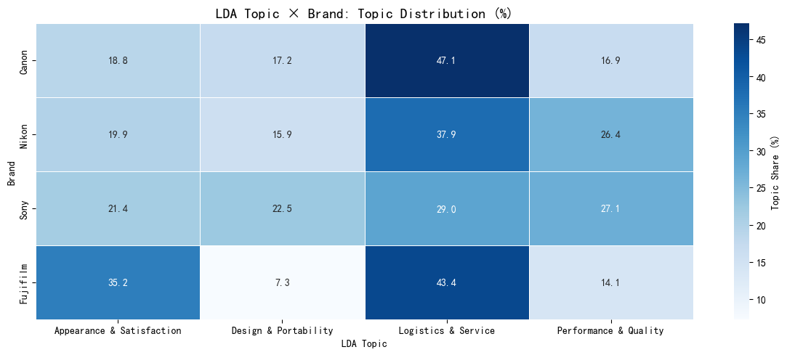
This chart shows what proportion of each brand's reviews fall into each LDA topic — it answers "what do users of each brand talk about most?"
Analysis:
Logistics & Service dominates all brands (29.0–47.1%), with Canon highest at 47.1% — nearly half of Canon reviews discuss purchase/delivery experience, consistent with its beginner audience who care more about buying experience than technical specs.
Fujifilm has the most polarized distribution: highest in Appearance (35.2%) and lowest in Design & Portability (7.3%). Users buy Fujifilm for aesthetics, not portability.
Sony is the most balanced brand: no single topic exceeds 29%, and it leads in both Design & Portability (22.5%) and Performance & Quality (27.1%) — the only brand strong on both.
Nikon skews toward Performance (26.4%, second only to Sony) while maintaining moderate Appearance (19.9%) — a performance-first user base.
The biggest brand gap: Fujifilm's Appearance (35.2%) vs. Canon's (18.8%) = 1.87×. The second biggest: Sony's Performance (27.1%) vs. Fujifilm's (14.1%) = 1.92×. These two dimensions define the core market divide.

4.3 Topic Preference Comparison by Brand
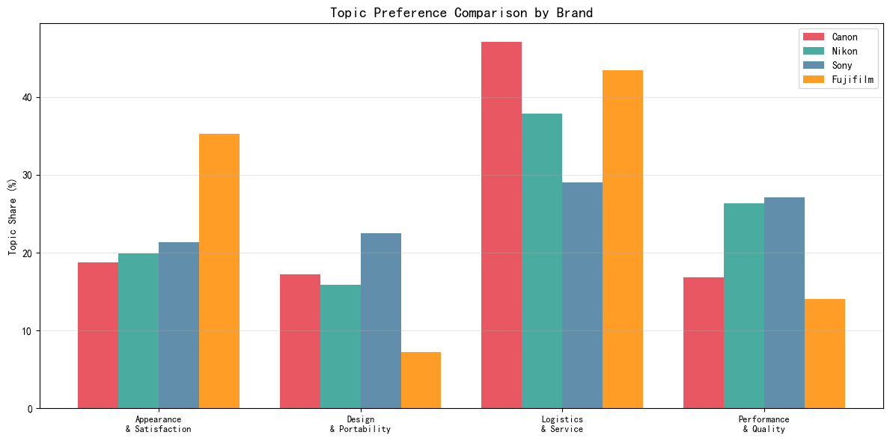
This chart visualizes the same data as the distribution heatmap but makes cross-brand comparison within each topic easier to read.
Analysis:
Logistics & Service: Canon (47.1%) and Fujifilm (43.4%) dominate, while Sony is notably lower (29.0%). Canon's high share reflects beginner users focused on purchase experience; Fujifilm's high share reflects supply-related complaints ("抢到", "原价") being classified into this topic.
Appearance & Satisfaction: Fujifilm (35.2%) stands far above the other three brands (18.8–21.4%), which cluster closely together. This is the single clearest brand differentiator in the chart.
Performance & Quality: Sony (27.1%) and Nikon (26.4%) lead, Canon (16.9%) and Fujifilm (14.1%) lag behind. The ~2× gap confirms the performance vs. aesthetics divide.
Design & Portability: Sony (22.5%) is a clear outlier — nearly 3× Fujifilm's 7.3%. Canon (17.2%) and Nikon (15.9%) sit in the middle. Fujifilm's extremely low share suggests its users rarely discuss portability, focusing instead on appearance and purchase experience.
Key takeaway: Each brand has a distinct "spike" — Canon spikes on Logistics, Fujifilm on Appearance, Sony on Design & Portability, Nikon on Performance.

4.5 Topic Attention Trend Over Time
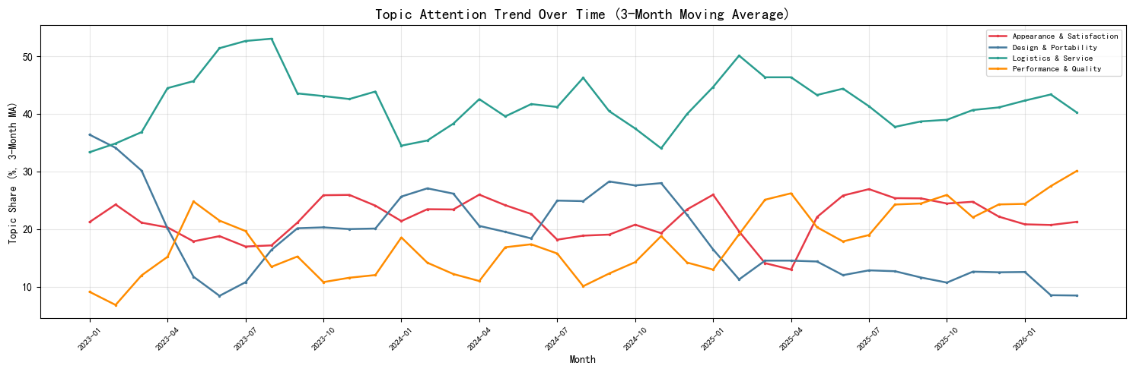
This chart tracks how the share of each LDA topic changes month-by-month, showing whether consumer discussion priorities are shifting over time.
Analysis:
Ignore pre-2023 data — the extreme values (Appearance at 100% in early 2022) are artifacts of very low review counts in those months, making percentages unreliable.
From mid-2023 onward, the trends stabilize and show a clear pattern:
Logistics & Service (green) consistently holds the largest share (35–50%), confirming that purchase experience is the dominant discussion theme on JD.com throughout the entire observation period.
Appearance & Satisfaction (red) stabilizes around 20–25%, showing steady importance without significant growth or decline.
Performance & Quality (orange) fluctuates between 15–30%, with a slight upward trend in late 2025 — potentially reflecting growing interest in technical performance as the market matures and users become more sophisticated.
Design & Portability (blue) shows a gradual decline from ~25% in 2023 to ~10% by 2026, suggesting that portability discussions are becoming less prominent as users increasingly take compact mirrorless design for granted.
Key takeaway: The topic composition is largely stable over time, meaning brand positioning strategies don't need to chase shifting consumer priorities — the market's discussion structure is settled. The one notable shift is Design & Portability's decline, suggesting portability is becoming a baseline expectation rather than a differentiating discussion point.

品牌优劣势总结：
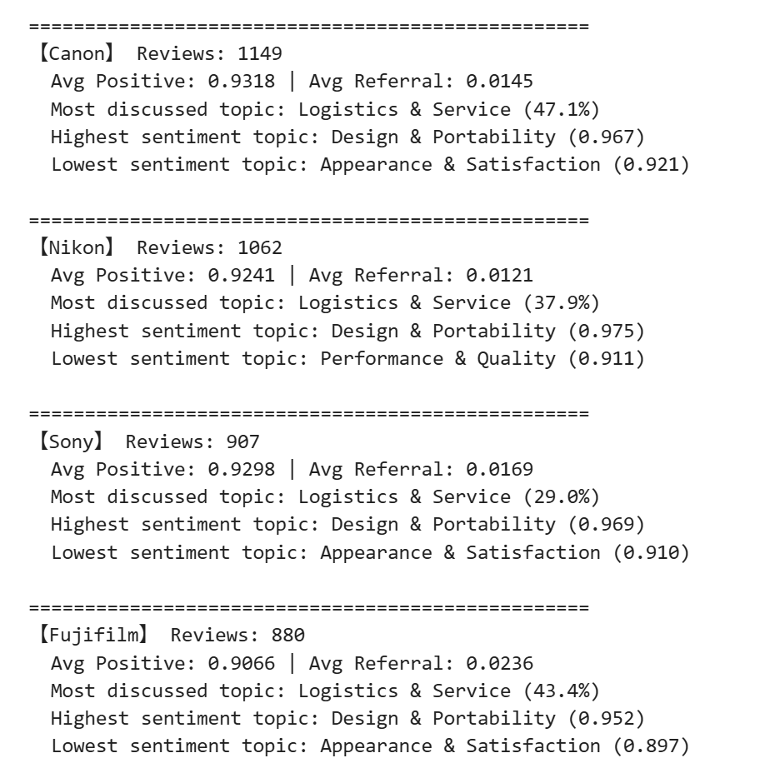
Canon (n=1149) has the highest overall positive score (0.932) and the most balanced topic profile. Its dominance in Logistics & Service (47.1%) reflects a beginner-oriented user base that values purchase experience. Sentiment is consistently high across all topics with no major weakness.
Nikon (n=1062) shows a clear performance-first identity — highest sentiment in Design & Portability (0.975) but lowest in Performance & Quality (0.911), suggesting Z30 users love the body but expect more from Nikon's optical heritage. It has the lowest referral score (0.012) among all brands.
Sony (n=907) is the most balanced brand, with the most evenly distributed topic profile and strong positive score (0.930). It leads in both Design & Portability and Performance discussion share, positioning it as the versatile "all-rounder" for users who evaluate cameras comprehensively.
Fujifilm (n=880) has the lowest positive score (0.907) but the highest referral score (0.024) — users complain more but recommend more. This paradox reflects supply frustration depressing sentiment while strong brand loyalty drives word-of-mouth. Its extreme skew toward Appearance (35.2%) and away from Design & Portability (7.3%) makes it the most niche-positioned brand.

